**Personal Learning Plan**

Delivery Date: 27th of November – 2016

Subject: Web Design – Buy Now page

Strengths: Enjoy coding

Weaknesses: Lack of free time

1. **SPECIFIC:**

The Buy Now page will contain images of the product with their price described. In this page the customer will be able to pick the product of their interest, able to buy in a bundle or separately.

In the image below we can check the wireframe of what needs to be achieved, all prices and images been given.

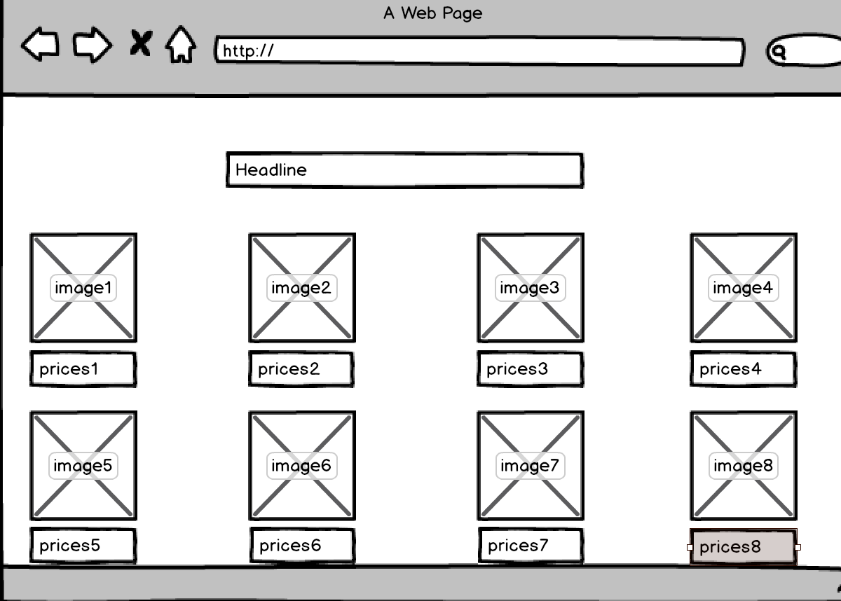

1. **MEASURABLE:**

The Buy Now page will have 8 images with description of prices in all of them. It should take from 2 to 3 hours of work to have it built. It will require HTML and CSS, a red headline in the centre, with the standard colors around.

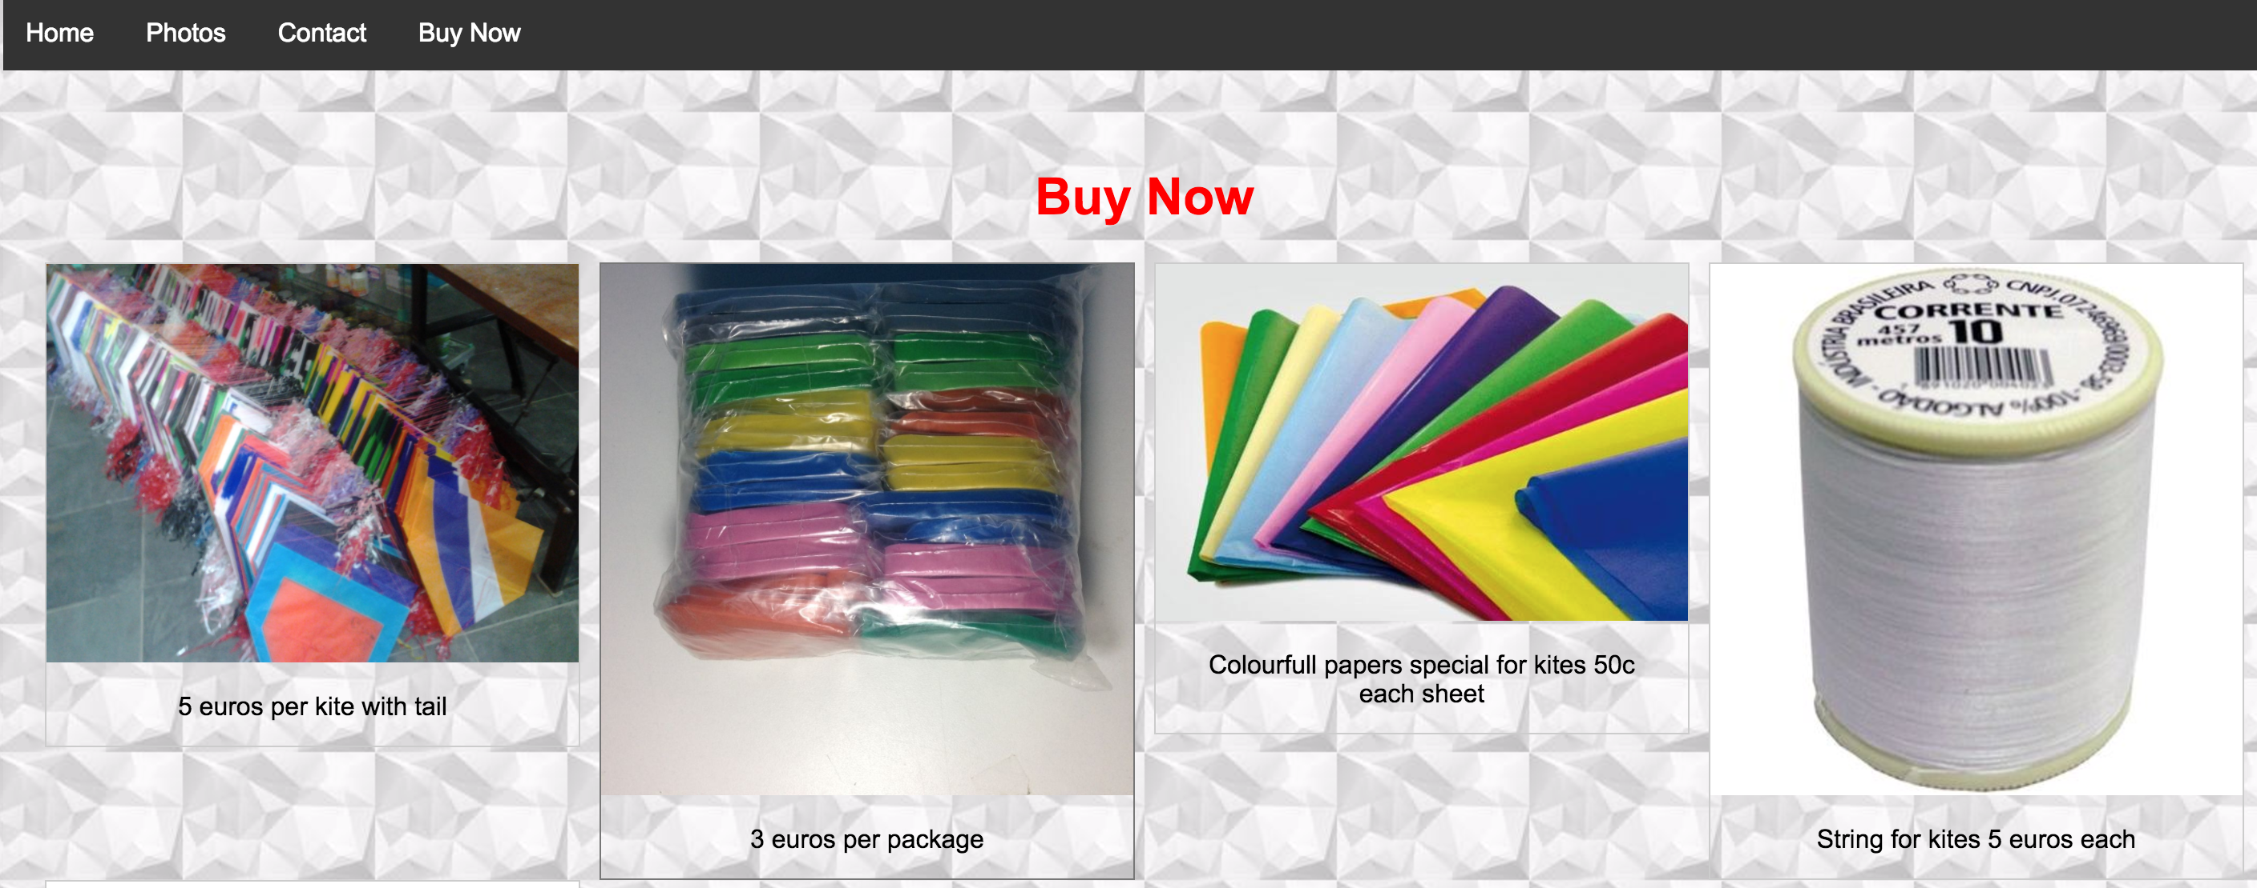

In the image above we can see the structure of it. The page will provide many options of products

1. **ACHIEVABLE:**

The goal is to start selling the products and make profit out of it and slowly progress in the market, ideally at least one new customer every month.

1. **RELEVANT:**

Having users buying the product is fundamental for the business growth. This page is the “heart” of the business, so having a clear image and price description is important.

1. **TIME-BOUND:**

Having 1 bundle deal closed per month, and 3 products individually sold per month, increase by one of each deal on the next month getting more popularity in the market.

We expect to be a little popular by next summer, where this product can be enjoyed in most of the days, also is a time where all children and tennagers are out of school. This is the best time for a potential increasing of popularity therefore growth of business.

The deadline for this page is in the 27 th of November